
CC-215-L: Database Systems Lab
Faculty of Computing & Information Technology

BS(IT&CS) Morning - Fall 2023
LAB – 04
The objective of this lab is:
- Practice Extended Group Functions
- Window Functions
- Ranking Functions
- Equi Join
Course & Lab Instructor: Dr. Asif Sohail
Task 01: [10 Marks]
      - Write an SQL query to retrieve Employee’s name, deptno, salary, bonus and Increased Sal. Bonus is computed as one-tenth of the mean salary of their department.
SELECT ENAME, DEPTNO, SAL, ROUND(0.1 * AVG(SAL) OVER (PARTITION BY DEPTNO),2) BONUS, SAL + ROUND(0.1*AVG(SAL) OVER (PARTITION BY DEPTNO),2) "Increased Sal"
FROM EMP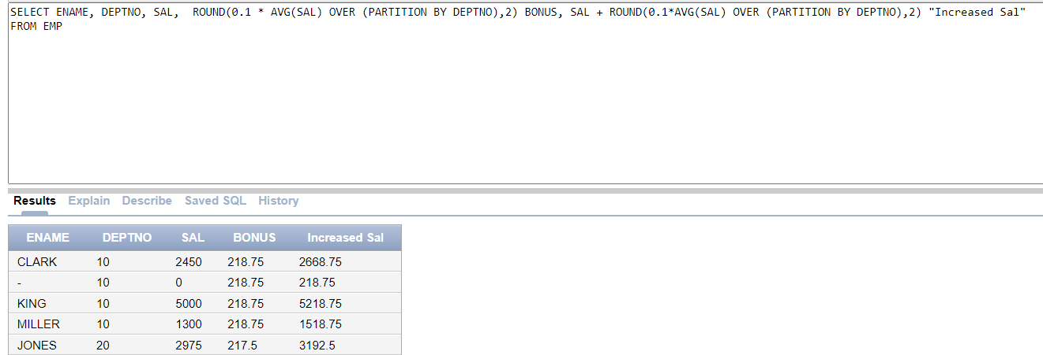
      - Group all the employee numbers based on their managers. Display the mean salary against all employees working under the same manager. Skip the null values.
SELECT EMPNO,MGR,ROUND(AVG(SAL) OVER (PARTITION BY MGR ORDER BY MGR),2) AS AVG_SAL
FROM EMP
WHERE MGR IS NOT NULL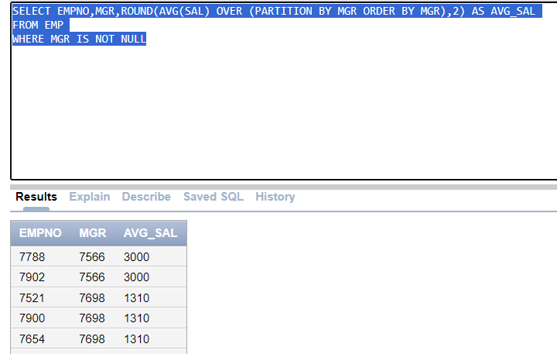

      - Assign grades to the employee salaries in Department Number 30 as follows.
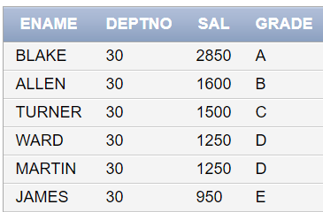
SELECT ENAME,DEPTNO,SAL,TRANSLATE(DENSE_RANK() OVER (ORDER BY SAL DESC),'123456789','ABCDEFGHI')GRADE
FROM EMP
WHERE DEPTNO = 30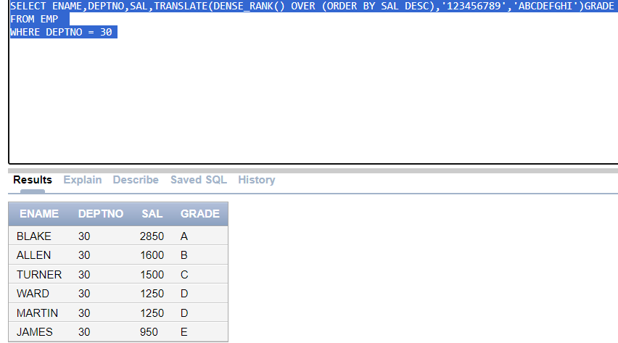
      - List the jobs in all the departments as follows.
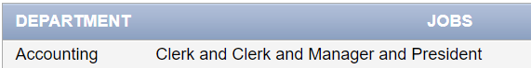
SELECT INITCAP(DNAME)AS DEPARTMENTS,LISTAGG(INITCAP(JOB),' and ') WITHIN GROUP (ORDER BY job)AS "JOBS"
FROM EMP e
JOIN DEPT d
ON e.DEPTNO = d.DEPTNO
GROUP BY DNAME
ORDER BY DNAME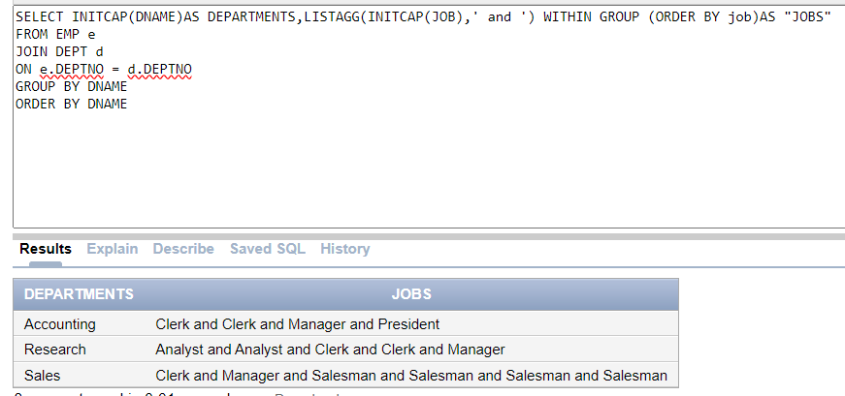
      - Display the employees along with the median hire dates for their respective jobs.
SELECT ENAME, MEDIAN(HIREDATE) OVER(PARTITION BY JOB)
FROM EMP
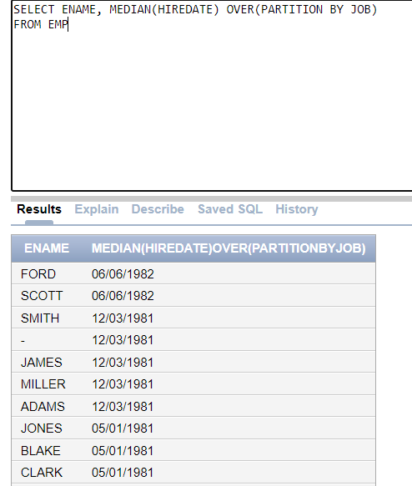
      - For each employee, show their salary, the average salary of all employees, the difference between their salary and this average, and the rank of this difference.
WITH Employee_Salary_Info AS (
SELECT ENAME,
SAL,
AVG(SAL) OVER () AS Avg_Salary,
(SAL - AVG(SAL) OVER ()) AS Salary_Difference
FROM EMP
)
SELECT ENAME,
SAL,
Avg_Salary,
Salary_Difference,
RANK() OVER (ORDER BY Salary_Difference DESC) AS Salary_Rank
FROM Employee_Salary_Info;
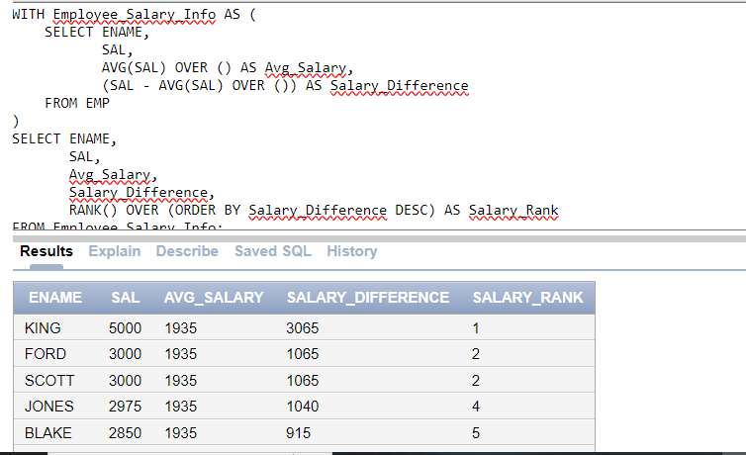

      - Find departments with more than 5 employees and list their details.
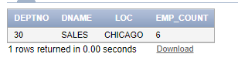
SELECT e.DEPTNO,DNAME,LOC,COUNT(EMPNO) AS "EMP_COUNT"
FROM EMP e
JOIN DEPT D
ON e.DEPTNO = d.DEPTNO
GROUP BY e.DEPTNO,DNAME,LOC
HAVING COUNT(EMPNO) > 5;
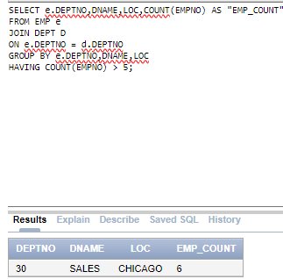
      - Get the highest salaries of all the departments from dept table. Display the output in the following format.
SELECT DNAME,MAX(SAL)
FROM EMP e
JOIN DEPT d
ON e.DEPTNO = d.DEPTNO
GROUP BY DNAME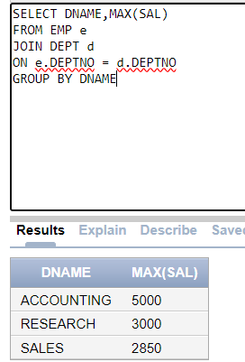
Task 02: [20 Marks]
- Write an SQL query to assign numbers to employees within each department, ordered alphabetically by name. The numbering based on lexicographical ranking should start from the highest number and decrease (i.e., descending order). For example, the employees in deptno 10 are numbered as follows.
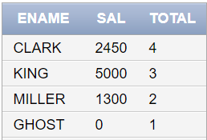
SELECT NVL(ENAME,'GHOST') ENAME, SAL, COUNT (*) OVER (PARTITION BY DEPTNO ORDER BY ENAME ROWS BETWEEN CURRENT ROW AND UNBOUNDED FOLLOWING) AS TOTAL FROM EMP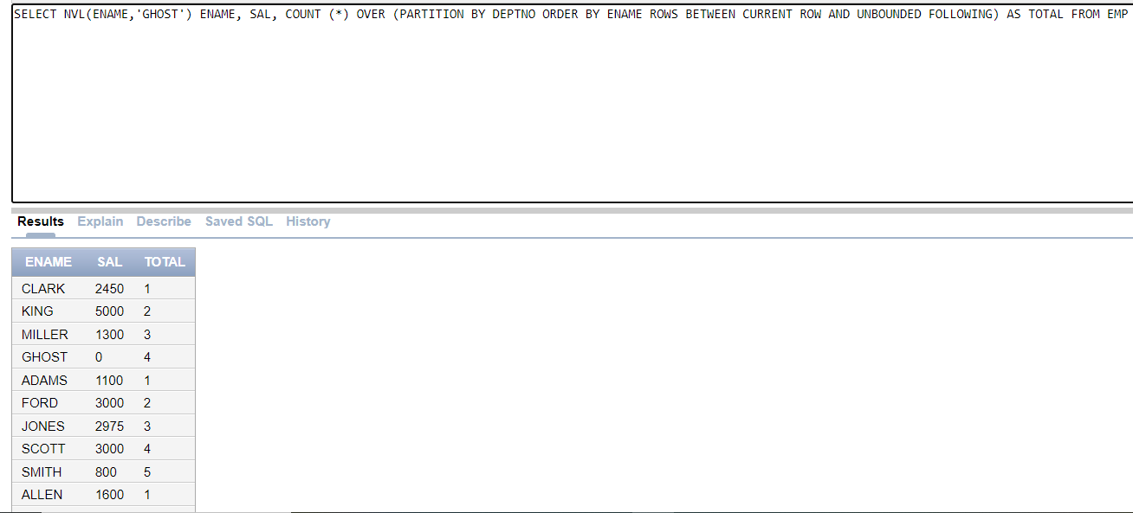
- List the employees based on the number of vowels in their names, with the employee having the highest number of vowels ranked first.
SELECT ENAME,LENGTH(ENAME) - LENGTH(REPLACE(TRANSLATE(ENAME,'AEIOU',' '),' ','')) VOWELS
FROM EMP
WHERE ENAME IS NOT NULL
ORDER BY VOWELS DESC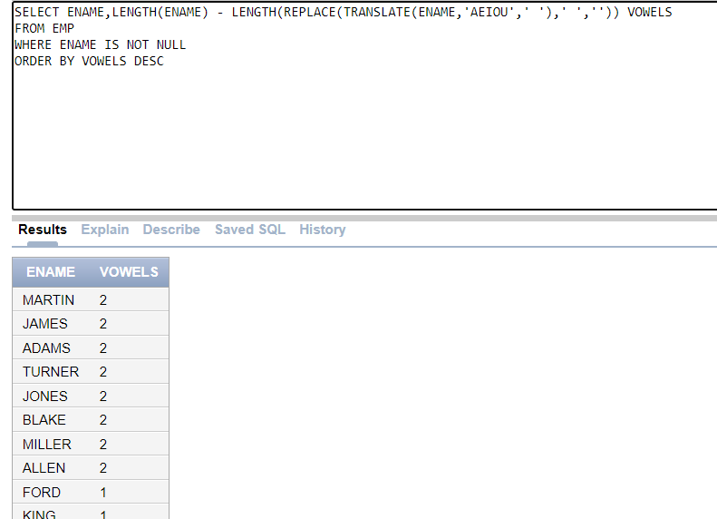

- Retrieve the employee names along with their salaries. For each employee, calculate a running total of the salaries of consecutive employees (the row itself along with its preceding and following rows), where salaries of employees in odd positions in the table are subtracted from the total, while salaries of employees in even positions are added.
SELECT ENAME, ROWNUM, SUM(CASE WHEN MOD(ROWNUM,2)=1 THEN -1*SAL ELSE SAL END) OVER(ORDER BY ROWNUM ROWS BETWEEN 1 PRECEDING AND 1 FOLLOWING)AS SAL
FROM EMP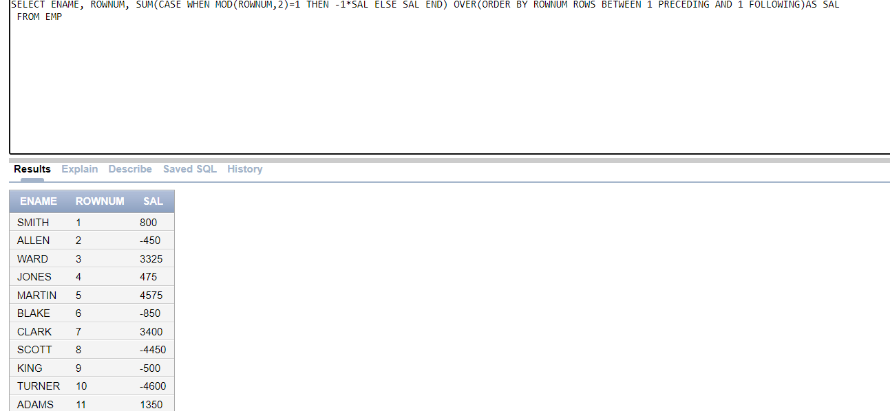
- Summarize a report that displays each job along with all the associated departments and the total salary earned for each job. Additionally, provide the reverse view showing all departments along with their respective jobs and the total salary earned in each department.
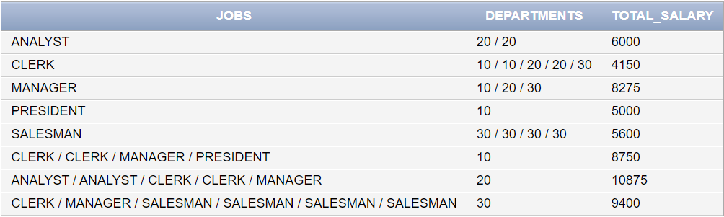
SELECT NVL(JOB,LISTAGG(JOB,'/') WITHIN GROUP(ORDER BY JOB)) AS JOBS,
NVL(TO_CHAR(DEPTNO),LISTAGG(DEPTNO,'/') WITHIN GROUP (ORDER BY DEPTNO))AS DEPARTMENTS,
SUM(SAL)AS TOTAL_SAL
FROM EMP
GROUP BY GROUPING SETS(JOB,DEPTNO)
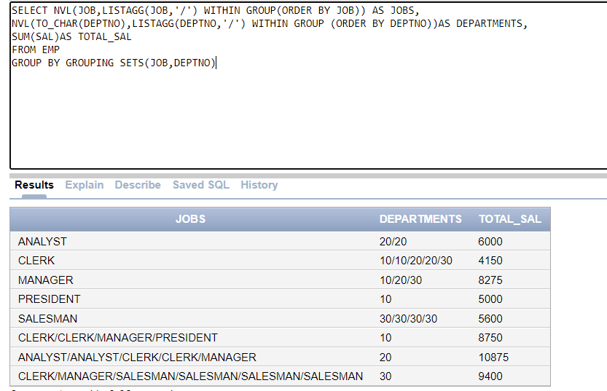
- We want to assign a special code for each employee in emp table based on its salary. The sal is rounded it to its nearest thousand value. The special code is assigned on the basis of the following rules:
a. A for 1000
b. B for 2000
c. C for 3000
d. D for 4000
e. E for 5000
f. S for 0
Note: You are not allowed to use decode or case for this question.
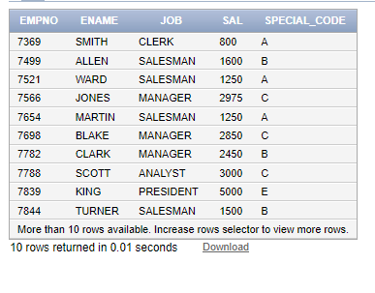
SELECT EMPNO,ENAME,JOB,SAL,TRANSLATE(DENSE_RANK()OVER(ORDER BY ROUND(SAL,-3)),'123456','SABCEF')AS "SPECIAL CODE"
FROM EMP
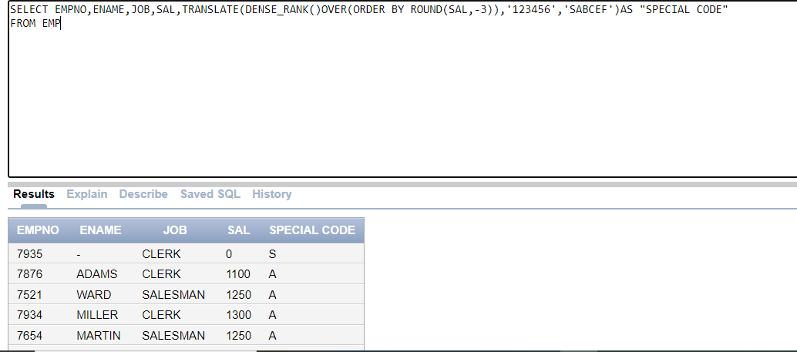
- For each department, display the Department Name along with highest salary, lowest salary, total salary, and average salary, only if the department has at least 3 employees.
SELECT DNAME,MAX(SAL),MIN (SAL),SUM(SAL),ROUND(AVG(SAL),2)
FROM EMP E
JOIN DEPT D
ON E.DEPTNO = D.DEPTNO
GROUP BY DNAME
HAVING COUNT(EMPNO) >= 3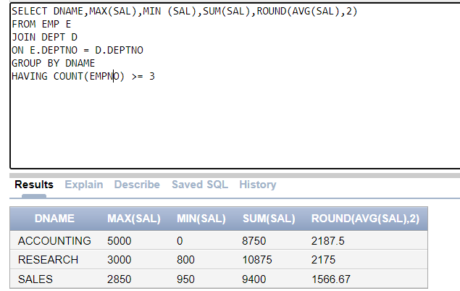
- Display the department name and the average salary of employees in that department. Only include departments where the highest salary is more than twice the lowest salary within the same department.
SELECT DNAME,ROUND(AVG(SAL),2)
FROM EMP e
JOIN DEPT d
ON e.DEPTNO = d.DEPTNO
GROUP BY DNAME
HAVING MAX(SAL) > 2* MIN (SAL);
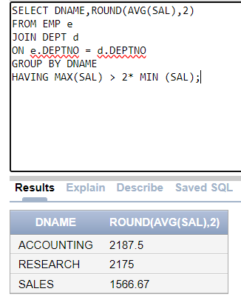
- Assign a unique rank to each employee within their department based on their salary, sorted from highest to lowest.
SELECT ENAME,EMPNO,SAL,DEPTNO,ROW_NUMBER() OVER (PARTITION BY DEPTNO ORDER BY SAL DESC) AS RANK
FROM EMP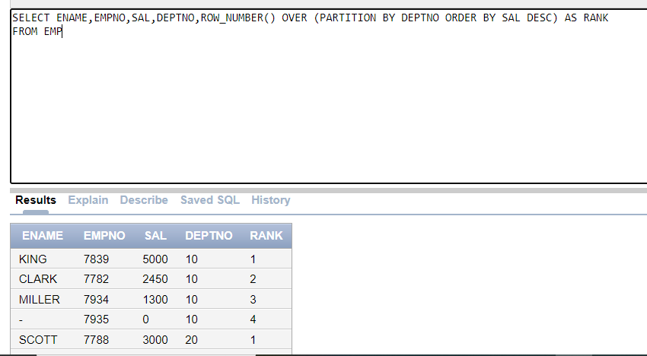
Task 03: [5 Marks]
- Write an SQL query to display each employee's name, but only show the character in the name that corresponds to the number of employees in that employee's department. If the name is shorter than the employee count, display the first character. Group the results by department and list the names in a concatenated format for each department.

WITH EMP_COUNT_TAB AS (SELECT ENAME, DEPTNO, COUNT(*) OVER(PARTITION BY DEPTNO) EMP_COUNT FROM EMP)
SELECT DEPTNO, LISTAGG(SUBSTR(NVL(ENAME,'GHOST'),NVL2(NULLIF(SIGN(EMP_COUNT-LENGTH(NVL(ENAME,'GHOST'))),1),EMP_COUNT,1),1), ' | ') WITHIN GROUP (ORDER BY ENAME) AS NAMES FROM EMP_COUNT_TAB GROUP BY DEPTNO

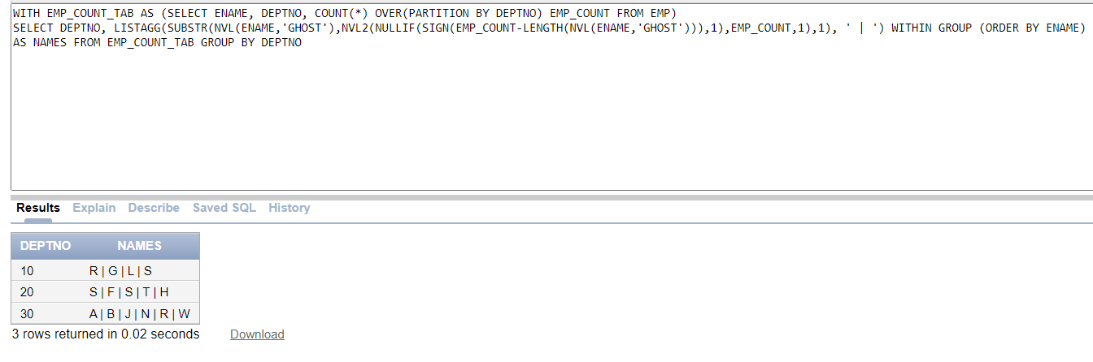
- Write a query that lists departments and, for each department, concatenates the names of employees who have salaries above the department's average salary. The concatenated list should be sorted by the reverse alphabetical order of the employee names, and all names should be converted to lowercase. If there are no employees with salaries above the average for that department, display "NO HIGH SALARY EMPLOYEES" for that department.
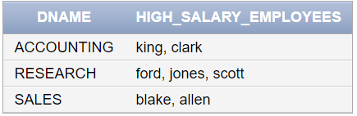
WITH EMP_SAL AS (SELECT DNAME, NVL2(NULLIF(SIGN(SAL-AVG(SAL) OVER (PARTITION BY E.DEPTNO)),1),NULL,LOWER(ENAME)) NAME, SAL, AVG(SAL) OVER(PARTITION BY E.DEPTNO) FROM EMP E JOIN DEPT D ON E.DEPTNO=D.DEPTNO) SELECT DNAME, LISTAGG(LOWER(NAME),', ') WITHIN GROUP(ORDER BY REVERSE(NAME)) HIGH_SALARY_EMPLOYEES FROM EMP_SAL GROUP BY DNAME
Task 04: [5 Marks]
VIVA VOCE

